i. Construct an E-R diagram for a car-insurance company whose customers own one or more cars each. Each car has associated with it zero to any number of recorded accidents.

ii. If, no attribute has the capability to become a primary key in a relation, how you will ensure entity integrity constraint? Explain with suitable example and write SQL query for ensuring it.

iii.Compare Following (with suitable example): a. Primary key and Unique key b. Multivalued attribute and Composite attribute iv. Describe three–schema architecture and explain the role of physical data independence and logical data independence.

i. Explain different types of anomalies with suitable example.

ii. Given a relation R ( A, B, C, D) and Functional Dependency set FD = {AB → CD, B → C}, determine whether the given R is in 2NF?

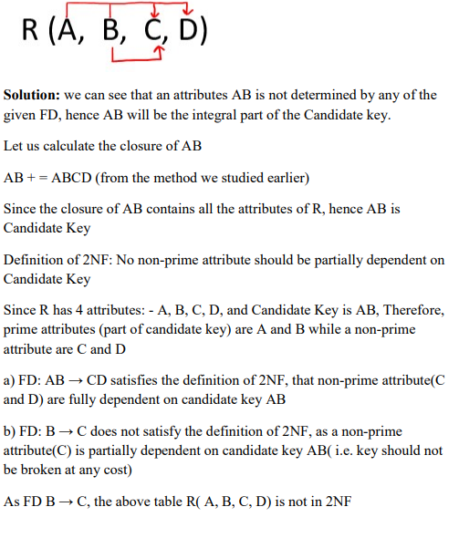

A. Write Relational Algebra queries for the following schema:

Instructor (ID, name, dept_name, salary)

Teaches (ID, course_id, sec_id, semester, year)

Course (course_id, Title, Fee, credits)

I. Find the names of all instructors together with the course id of all courses they taught.

II. Find the names of all instructors in the Physics department together with the course id of all courses they taught.

III. Find the names of all instructors in the Comp. Sci. department together with the course titles of all the courses that the instructors teach.

B. Convert following SQL in to relational algebra:

i. SELECT movieTitle FROM StarsIn, MovieStar WHERE starName = name AND birthdate = 1960

ii. (SELECT name, address from MovieStar) EXCEPT (SELECT name, address from MovieExec)

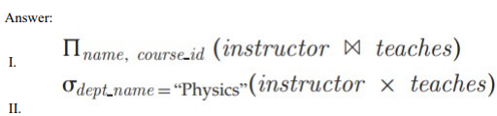

List four significant differences between a file-processing system and a DBMS.

Answer: Some main differences between a database management system and a file-processing system are: • Both systems contain a collection of data and a set of programs which access that data. A database management system coordinates both the physical and the logical access to the data, whereas a file-processing system coordinates only the physical access. • A databasemanagement system reduces the amount of data duplication by ensuring that a physical piece of data is available to all programs authorized to have access to it,whereas data written by one programin a file-processing system may not be readable by another program. • A database management system is designed to allow flexible access to data (i.e., queries), whereas a file-processing system is designed to allow predetermined access to data (i.e., compiled programs). • A database management system is designed to coordinate multiple users accessing the same data at the same time. A file-processing systemis usually designed to allow one or more programs to access different data files at the same time. In a file-processing system, a file can be accessed by two programs concurrently only if both programs have read-only access to the file

Explain DDL and DML commands with suitable examples.

Ans. DDL Commands: DDL means Data Definition Language. It is used to create and modify the structure of database objects in SQL. As a DDL example, lets say we are creating a table, index and or removing a table from a database and modifying a table i.e. modifying columns etc. then we use DDL commands. DDL Commands in SQL Examples: CREATE – Creates objects e.g. table in the database ALTER – Alters objects of the database. e.g. modifying a column of a table DROP – Deletes objects from the database. e.g. remove table from a sql database. TRUNCATE – Deletes all records from a table and resets table identity to initial value. DML Command: DML Command in SQL database stands for Data Manipulation Language. DML commands are used to retrieve, store, Modify, delete, insert and update data in database. In fact, we are manipulating data that’s why it is called data manipulation language. DML Command in SQL Examples: SELECT- This command or statement is used to retrieves data from a table INSERT – Inserts new data into a table UPDATE – Updates or modifies existing data into a table

Consider a relation schema R(X Y Z W P) is decomposed into R1(X Y) and R2 (Z W). Determine, whether the above R1 and R2 are Lossless or Lossy?

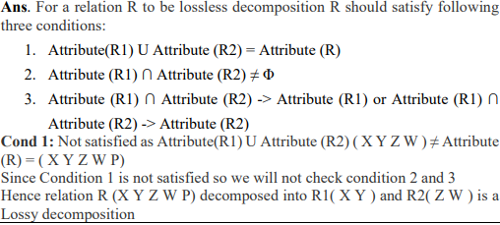

ACID properties

**1. What is Data Independence? Explain the different types of Data Independence. 2 Marks**

**Solution:**

* Data independence can be defined as the capacity to change the schema at one level of database system without changing the schema at the higher level. Only the mapping between the two levels is changed. There are two types of data independence:
* Logical: It is the capacity to change the conceptual schema without changing external schema or application program. We may change the conceptual schema to expand or reduce the database
* Physical: It is the capacity to change the internal schema without changing conceptual schema or external schema. We may change the internal schema to reorganize the physical files.

**2. Explain the distinctions among the terms primary key, candidate key, and super key. 2 Marks**

**Solution:**

* A super key is a set of one or more attributes that, taken collectively, allows us to identify uniquely an entity in the entity set. A super key may contain extraneous attributes. If K is a super key, then so is any superset of K.
* A super key for which no proper subset is also a super key is called a candidate key. It is possible that several distinct sets of attributes could serve as candidate keys.
* The primary key is one of the candidate keys that is chosen by the database designer as the principal means of identifying entities within an entity set.

**3. Consider these relations (tables), where the underlined attributers are the keys:**

**Supplier(scode, sname, status, scity) Part(pcode, pname, color, weight, pcity)**

**Supplier_Part(scode, pcode, qty)**

**Write SQL queries for each of these:**

**a) Display the supplier names who supply at least one red part.**

**b) Display the supplier names who do not supply part 425**

**Solution:**

* select distinct sname from supplier where supplier.scode in (select scode from supplier_part where supplier_part.pcode in(select pcode from part where part.color='red'));
* select distinct sname from supplier where not exists(select * from supplier_part where supplier_part.scode=supplier.scode and supplier_part.pcode=425);

**5. Suppose you are given the following requirements for a simple database for the Indian Premier League (IPL): 6 Marks**

**• IPL has many teams**

**• Each team has a name, a city, a coach, a captain, and a set of players**

**• Each player belongs to only one team**

**• Each player has a name, a position (batsman, bowler, all-rounder, wicket keeper), a skill level, and a set of injury records**

**• Team captain is also a player**

**• a game is played between two teams (referred to as host_team and guest_team) and has a date (such as May 11th, 1999) and a score (such 201/7, 199/6).**

**Construct a clean and concise ER diagram for the IPL database. List your assumptions and clearly indicate the cardinality mappings as well as any role indicators in your ER diagram.**

**Solution:**

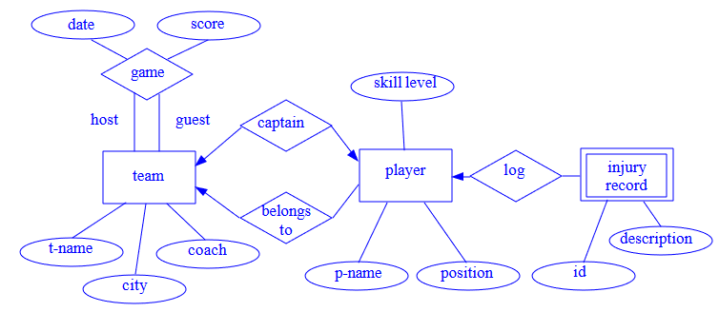

**6. Consider a relation R(A, B, C, D, E) with FD's:{ A → B, BC → E, ED → A}**

* **List all the keys of R**
* **Identify the functional dependencies that violate 2NF, 3NF, BCNF. Solution:**

Candidate keys are CDE, ACD, BCD

R is in 2NF, 3NF but not in BCNF